Clarion Rec Center Membership Management Program and Database User Guide



Clarion Rec Center Membership Management Program and Database User Guide

**Table of Contents Page**

Getting Started – Student Worker…………………………………………………………………………….… 3

Signing In………………………………………………………………………………………………….……… 4

Running Main Program……………………………………………………………………………………. 5

Daily Reporting………………………………………………………………………….…………………….. 6

Editing a Transaction……………………………………………………………………………………….. 6

Student Worker Logout…………………………………………………………………………………… 7

Getting Started – Admin User……………………………………………………………………………………… 8

Using the Admin Panel…………………………………………………………………………………….. 8

Adding and Editing a Membership ……………………………………………………………………….. 9

Adding and Editing a Worker……………………………………………………………………………….. 10

Editing Privileges ………………………………………………………………………………………………………… 11

Admin Logout……………………………………………………………………………………………………………… 12

Clarion Rec Center Membership Management Program and Database User Guide

This user manual will guide you through the steps in using the Clarion Rec Center Membership Management Program and Database.

**Getting Started – Student Workers**

This is the home screen you will see after booting the program. In the center of the screen you will see two buttons labeled “Customer Portal” and “Management Portal”. The “Customer Portal” button will run the screen that customers will use to fill in information to purchase a day pass, membership, or fill out a forgotten ID request.

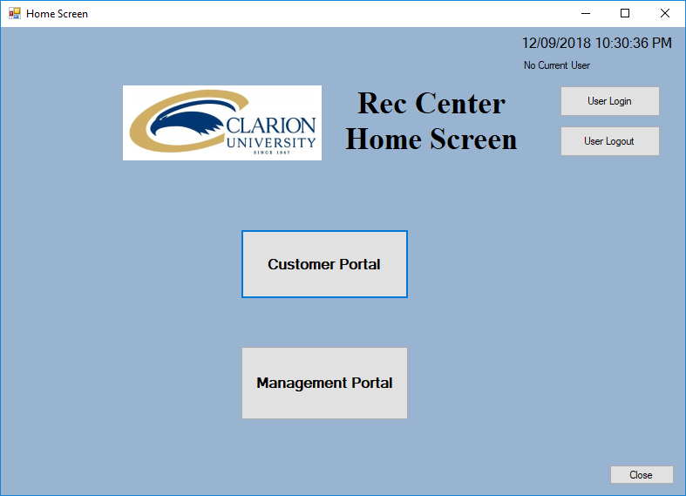Using the same username you would use for all other Clarion University login functions (s_username for example), and the four digit password assigned to you by the Rec Center Director, login to the program to begin using the program.

The program keeps track of all transactions made along with the student worker working the front desk. It is important to remember to login to the system after ever shift change. To sign out of the previous user, simply click the “Student Logout” button. To login to the system, click on the “Student Login” button to begin.

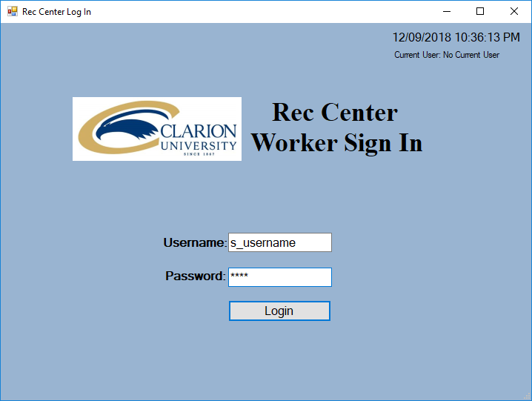**Signing In**

- This is the Worker Sign In form. To sign in simply enter your Clarion University s_username and the four digit password assigned to you by the Rec Center Director.

- Click the “Login” button

After you have successfully logged in, you may now press the “Customer Portal” button to begin using the main program functionality. This screen will allow customers to enter their information and select their desired purchase from the screen below.

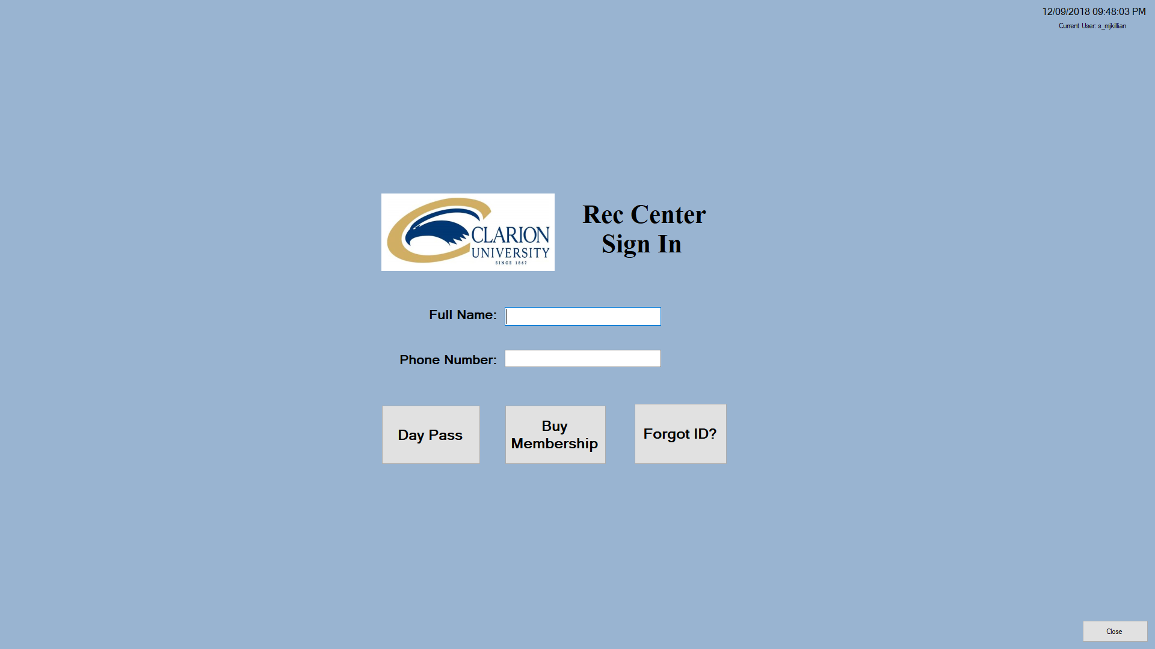

**Running the Main Program**

After you have successfully logged in to the system and clicked the “Customer Portal” button, customers can now use the program to fill out their information. After inputting their information, customers will choose either “Day Pass”, “Buy Membership”, or “Forgot ID?”

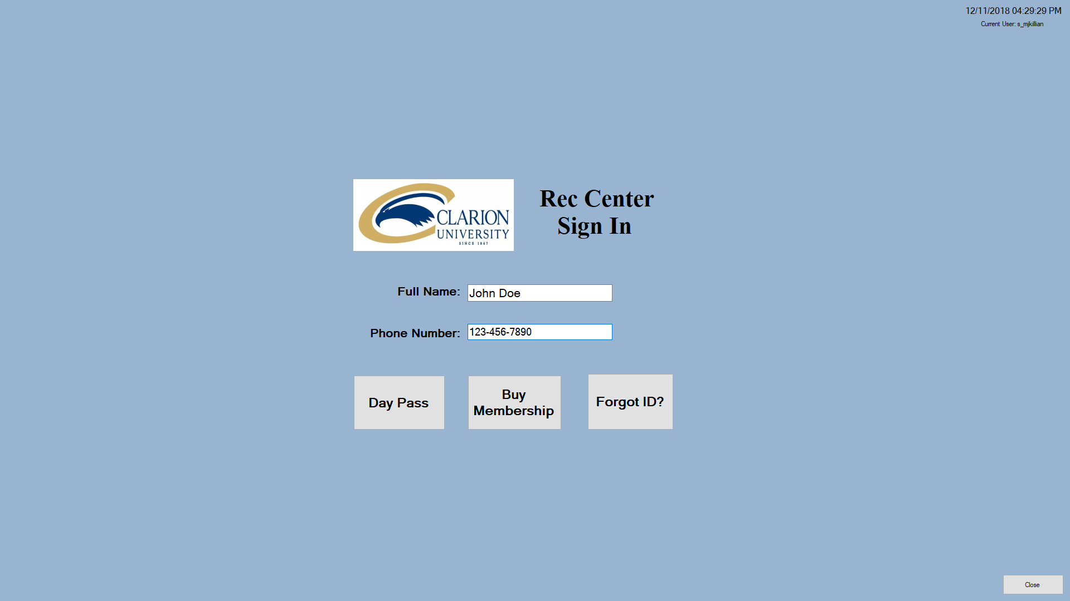

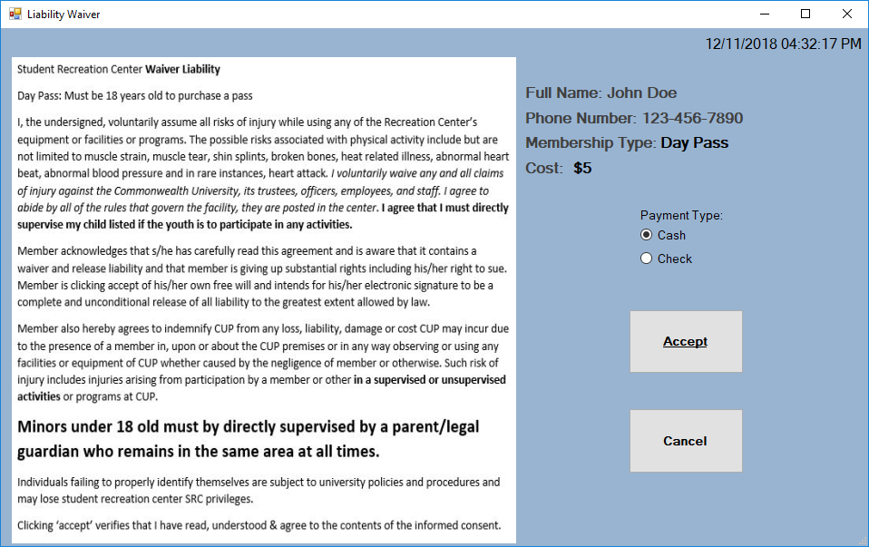

Customers will select the appropriate pass they wish to purchase, accept the liability waiver, then make a payment to the student worker.

A transaction will be recorded and sent to the Daily Reports screen.

**Daily Reporting**

To access the daily reports screen, select the “Management Portal” button from the home screen. This will launch the Daily Transaction Reports form. This form allows the student workers to print off the daily report, export the report to an Excel file, and edit and transaction if necessary.

To print the daily report, simply select the “Print” button towards the bottom of the page.

Remember to select the proper printer.

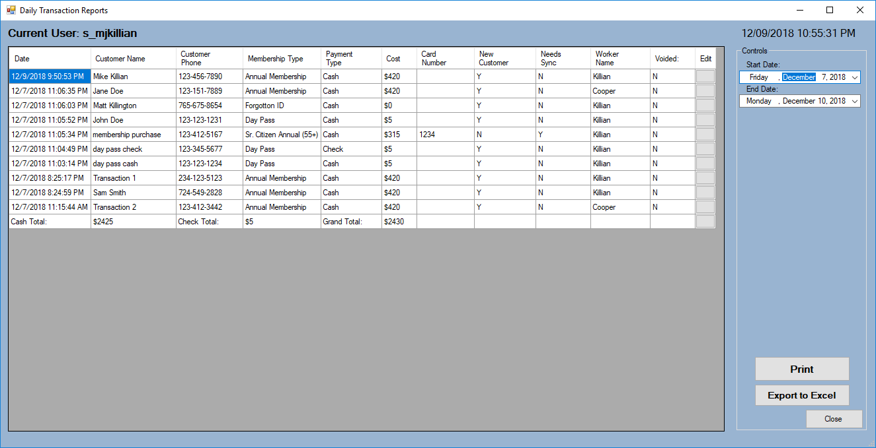

To export the daily transaction list into an Excel file, select the “Export to Excel” button, select a location for the file to saved, and press “Save”.

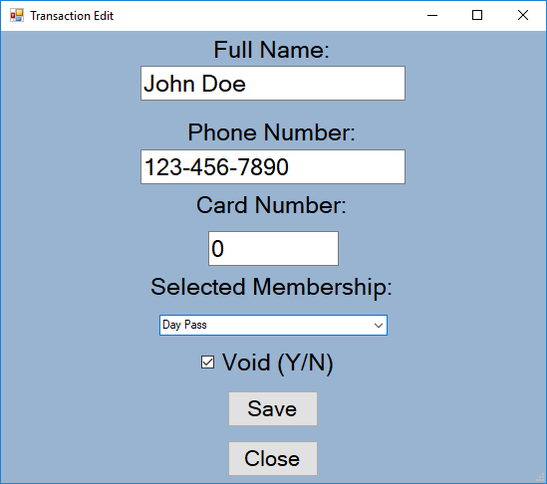

**Editing a Transaction**

If the customer selects the wrong pass from the Customer Portal, a worker may edit the transaction. Workers can edit the name, phone number, card number, the membership selected, and void the transaction if necessary. From the Daily Reports screen, the select button that says “Edit”. This will bring up the “Transaction Edit” window. Make the necessary changes and select “Save”. The worker who is logged in and records the transaction last will be saved under “Worker Name”.

**Student Worker Logout**



To Logout of the system, return to the Home Screen. From here you can select the “User Logout” button. You must logout before the next user can login.

**Getting Started – Admin User**

**Using the Admin Panel**

In addition to being able to run the main program and complete the daily report, the admin will be granted the option to perform several other functions. With admin privileges, sign in just like the student worker would, and select “Management Portal”.

This is what “Admin Panel” will look like. The admin panel give a view of all transactions that can be used to generate reports using the filters on the side.

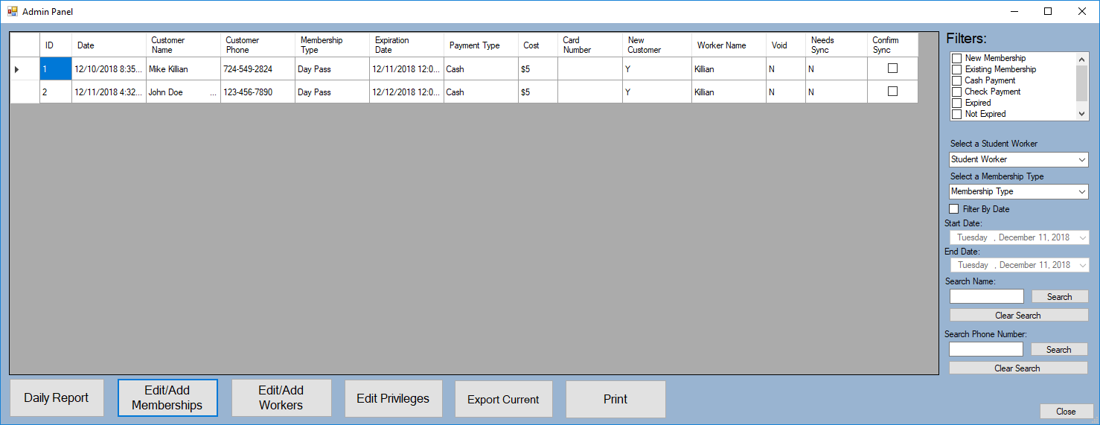

Admin Users have the ability to “Edit/Add Memberships”, “Edit/Add Workers”, and “Edit Privileges”. In addition to running the Daily Report and Export to Excel.

Admins can use the filters on the side to search transactions by name, phone number, the student worker who was present at the time of the transaction, etc…

To clear a name or phone number search box, select the “Clear Search” button. This will allow you to make a new search.

An admin can also “Confirm Sync” after entering the membership information to CBoard.

**Adding and Editing a Membership**

From the Admin Panel, click the “Add/Edit Membership” button.

This window will be opened. To add a new membership, click on the “Add New Membership” button.

-Add all necessary information and select “Save”. Select the “Active (Y/N)” checkbox to make the membership selectable from the Customer Portal.

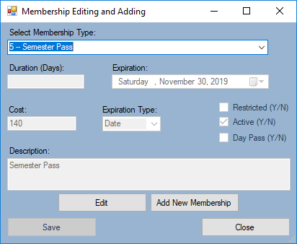

-Select the “Restricted” checkbox for the time restricted memberships and the “Day Pass” checkbox to classify the membership as a Day Pass

-To edit an existing membership, use the dropdown box to select the membership you wish to edit. Select the “Edit” button and make the necessary changes. Select the “Save” button.

-Close the window.

To assign a membership to a duration-based expiration date, enter the number of days the pass will be active for. For example, a two-month long membership will last 60 days. Select the “Dura” option from the Expiration Type dropdown box.

To assign a membership to a given date expiration date, Select the day the membership will expire from the Expiration date drop down box. For example, if a semester ends on Friday, December 14th, 2018, select that date from the dropdown box. Select the “Date” option from the Expiration Type dropdown box.

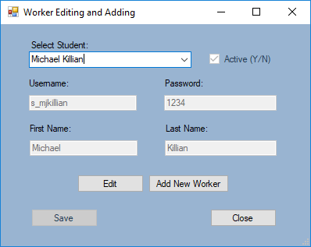**Adding and Editing a Worker**

To add or edit a worker, select the “Edit/Add Workers” button from the Admin Panel.

-To add a new worker, press the “Add New Worker” button. Enter all necessary information and select “Save”.

-To make a selected worker an active student, select their name, hit “Edit” and make sure the “Active (Y/N)” checkbox is checked.

-To edit an existing worker, find the worker’s name in the dropdown box, select “Edit” and make all necessary changes. Select “Save”.

-Close the window.

**Editing Privileges**

After you successfully add a new worker to the system, their name will automatically appear within the “Edit Privileges” window. To open this window, select the “Edit Privileges” button on the Admin Panel.

When a worker is logged in, you may grant them access to be an Admin or a Student worker. Simply highlight the user you wish to edit and select “Edit”.

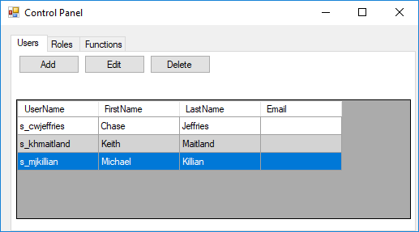

Highlight the role you wish to assign the worker and select the arrow to move the role from the “Is Not” side, to the “Is” side, and click “Submit”. Here we gave John Doe the role of “Student Worker”. Because John is given the role of Student Worker, he will not have access to the Admin Panel unless given authority with the Edit Privileges form. Once completed, close the window. To remove a role, highlight the role and select the arrow to move from the “Is” to the “Is Not”, click “Submit”.

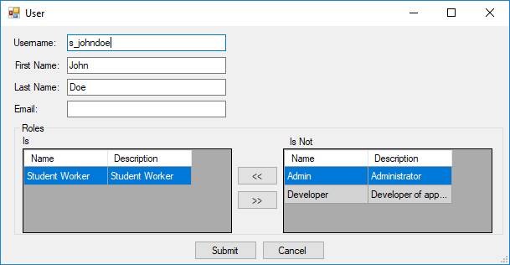

**Admin Logout**

To logout of the system, return the Home Screen and select the “User Logout” button.

